**RGBDigit Clock**

|  |  |
| --- | --- |
| Author | Asadullah Chaudhry |

# Content

Content 1

1 Introduction 2

2 Material and methods 3

2.1 ESP-12 3

2.2 Arduino IDE 3

2.3 Multi-color 7-segment 3

2.4 Schematic 4

2.5 Flowdiagram 5

2.6 Component list 5

*3* Results 6

3.1 Altium Schematic 6

*3.2* Pcb design 7

3.3 Autocad 8

4 Discussion 9

5 Reference list 10

# Introduction

The project started with the question “What are the minimal requirements to design a system that is both safe and user friendly - for an RGB Digit Clock”. The content of the application note is the methods used for the project, the Information about the materials and it also includes the result.

This project RGB Digit Clock which means the clock can change into many colours. If we connect a BME280 break-out board (BoB), then it is possible for this circuit to also display temperature, humidity, or air pressure very well. It is an interesting piece of equipment that has many useful functions, it is definitely worth taking a deeper look at. In the course of this project, the following auxiliary materials were used as a starting point: Elektor magazine.

The application note is structured as follows. All the materials and methods that are used can be found/retrieved. This chapter also explains the purpose of each component.

# Material and methods

## Afbeelding met tekst, elektronica, circuit Automatisch gegenereerde beschrijvingESP-12

The clock is controlled by an ESP12 module, so it can be synchronized with a time server on the Internet, controlled with a mobile device or computer in the network, or receive sensor data via Wi-Fi. [1]

**“ESP-12** is a miniature **Wi-Fi module** present in the market and is used for establishing a wireless network connection for microcontroller or processor”. [2]

Figuur 1 Esp-12

## Arduino IDE

“The Arduino Integrated Development Environment (IDE) is a cross-platform application (for Windows, macOS, Linux) that is written in functions from C and C++. It is used to write and upload programs to Arduino compatible boards, but also, with the help of third-party cores, other vendor development boards.” [2]

In this project, it will be used to write the main software of the RGBDigit Clock. There are many libraries and there is much support online for this IDE makes it easier to write the desired code.

## RGB 7-Segment Digit - 1 Tall Digit : ID 1399 : $14.95 : Adafruit Industries, Unique & fun DIY electronics and kitsMulti-colour 7-segment

Figuur 2 7-Segment

This display has eight 5050-RGB NeoPixel LEDs (seven segments plus decimal point) with integrated three-chip chips, allowing the user to control the color and brightness of each individual segment via a 3-wire bus (VCC, GND, and DATA). Up to 10 displays can be strung together via the DATA IN and DATA OUT pins. Each LED of a NeoPixel emits a primary color (R, G, or B). And each LED can be set to 256 brightness levels, resulting in an astonishing 256 x 256 x 256 = 16,777,216 possible colors for each segment.

## Schematic

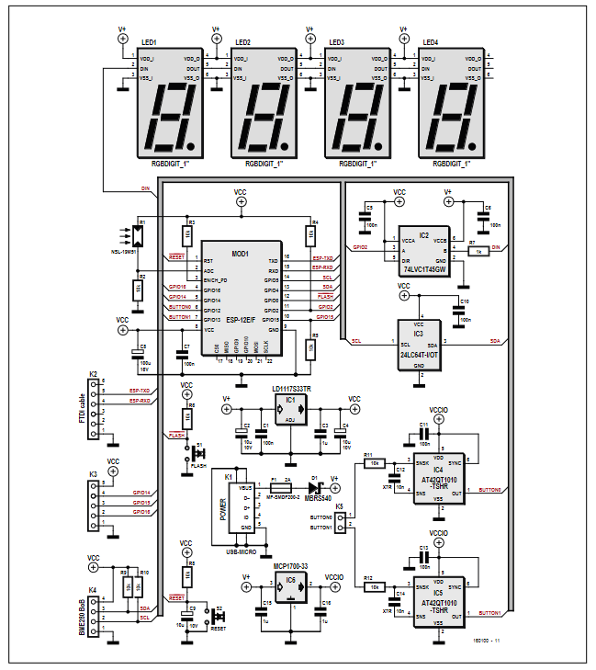

Figuur 3 RGB Digit Clock schematic

In figure 3 the full scheme of this project is shown. The clock is powered with 5 V via micro USB connector K1. The power supply is protected by fuse F1, a 2A self-resetting fuse with a PTC. Schottky diode D1 protects the circuit against polarity reversal. IC1 is the 3.3V voltage regulator for most of the circuit and IC6 is the voltage regulator for the Qtouch touch sensors IC4 and IC5 (which have a separate power supply to prevent interference). The two touch sensors Button0 and Button1 are used to control the display mode of the clock. S1 and S2 are used only for clock resetting and firmware flashing IC2 serve as a level adjuster between the 3.3V of the ESP-12E and the power supply (about 4.5V) of the displays. In EEPROM IC3 the clock settings are saved in the event of a power failure and LDR R1 is used to dim the displays in the dark. On K2, a 3.3V-FTDI cable (or another 3.3V-USB UART) be connected to flash the ESP-12E module; it can also be used for debugging applications. Via K3, the 3.3V power supply, and three I / O pins of the ESP12E are accessible for in-house developments and/or future expansions.

## Flowdiagram

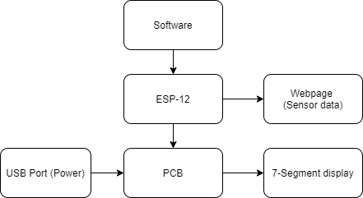

Figuur 3: Flowchart RGBDigit

## Component list

|  |  |  |  |  |
| --- | --- | --- | --- | --- |
| **Component type** | **Value** | **Quantity** | **Ordered from** |  |
|  |  |  |  |  |
| Resistor (R1) | LDR NSL-19M51 | 1 | Aliexpress |  |
| Resistor (R2 - R12) | 10KΩ | 10 | Aliexpress |  |
| Resistor (R7) | 1KΩ | 1 | Aliexpress |  |
| Capacitors (C1,C5,C6,C7,C10,C11,C13) | 100nF, 50V, X7R, 0805 | 7 | octopart.com |  |
| Capacitors (C2,C4,C9) | 10µF, 10V, tantalum, 1206 | 3 | octopart.com |  |
| Capacitors (C3,C15,C16) | 1µF, 50 V, X5R, 0805 | 3 | Gotron |  |
| Capacitors (C8) | 100µF, 16V, 2312 | 1 | Gotron |  |
| Capacitors (C12,C14) | 10nF, 50V, X7R, 0805 | 2 | Gotron |  |
| Semiconductors (D1) | MBRS540 | 1 | Gotron |  |
| Led's | 7-segment RGB display | 4 | microelectronics |  |
| IC1 | LD1117S33TR | 1 | microelectronics |  |
| IC2 | 74LVC1T45GW | 1 | microelectronics |  |
| IC3 | EEPROM 8K × 8 bit, type 24LC64T-I/OT | 1 | microelectronics |  |
| IC4,IC5 | Qtouch Touch Sensor type AT42QT1010-TSHR | 1 | microelectronics |  |
| IC6 | MCP1700T-3302E/TT | 1 | microelectronics |  |
| Fuse (F1) | 2A PTC resettable fuse, type MF-SMDF200-2 | 1 | microelectronics |  |
| Micro-USB | Micro-USB type B receptacle, underside mount | 1 | microelectronics |  |
| Header | 6-pin SIL pinheader, 0.1” pitch, right angled | 1 | microelectronics |  |
| Header | 5-pin SIL pinheader, 0.1” pitch, right angled | 1 | microelectronics |  |
| Header | 4-pin SIL pinheader, 0.1” pitch, straight | 1 | microelectronics |  |
| Header | 2-pin SIL pinheader, 0.1” pitch, right angled | 1 | microelectronics |  |
| Micro controller | ESP8266-12F | 1 | Aliexpress |  |
| Switch (S1) | Tactile switch | 1 | microelectronics |  |

# Results

## Altium Schematic

Figure 4: Scheme of pcb

The scheme shown above is based on figure 3. In this scheme all components are placed in several blocks. These components are also used in this project. This scheme is made in software Altium.

## Pcb design

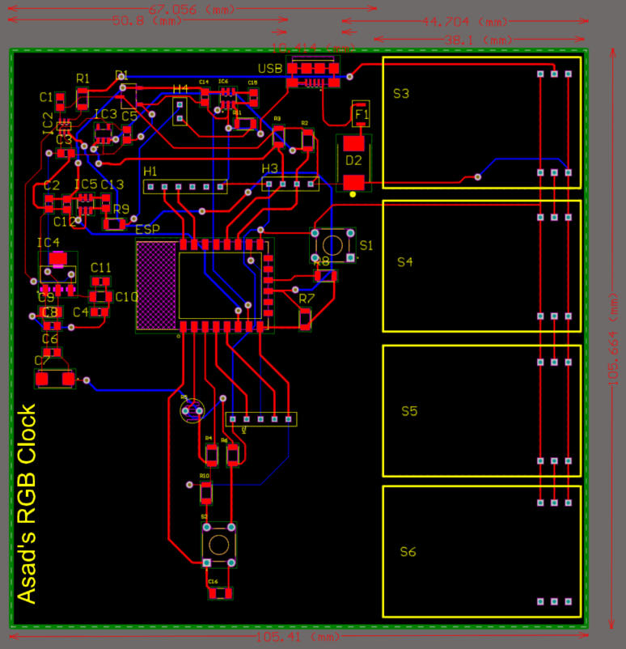

Figure 5: Asad’s RGB clock pcb

In figure 5 the components are placed on the Pcb. They are organized how the Pcb will look like in reality, but in different colours. Everything is measured in software Altium. The purpose of these measurements are to work in another software to make a case for the result of the Pcb. In comparison with figure 4 the red and blue lines are visible on the Pcb to not make any mistakes by placing the components.

## Autocad

Autocad is used to design the case in 3D. In figure 6 the slide of the case is shown. The function of this slide is to cover the Pcb.



Figure 6: Slide of the case

Figure 7 shows the foot of the case. It supports the case in general.

Figure 7: Foot of the case

The result of the Pcb case is shown in figure 8. The purpose of this case is to show the four RGB 7-segments In the opening so that the user can read the clock. There is also a USB-port on the left side of the case to charge the clock.

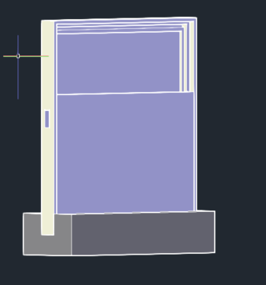

Figure 8: Case of clock

# Discussion

At the beginning it was really hard to choose a project for this year because there were a lot of possibilities.  
These project are from an older electrical magazine ‘Elektor’ so it made very difficult to find the right components from normal websites or stores such as Amazon and Gotron.

This project is not finished yet, because of covid-19 many problems were obtained. There were not many labs at school which made it really hard to work for the project. The Altium software is difficult to use and design the PCB. A lot of time was spend to design it and because of that there was no time to design in autocad in 3D and order the components from the websites. Most of the components come from China so that is why it took too long to arrive. Few components are still in transit which makes it kind of impossible to finish this project.

The hard part was to design the PCB because there were a lot of small components. It was easier to draw the components instead of looking for them in the library. This took a lot extra time.

To draw the 3D design in autocad was the easiest part in this project. Many mistakes were made during this part of the project. First, when the PCB was ordered and arrived, there were mistakes in the measurements. Everything was measured again and changed in Altium. A second mistake is ordering the components a bit later. Due to this mistake few components are still missing and because of that there was no time to order again and get it delivered at time.

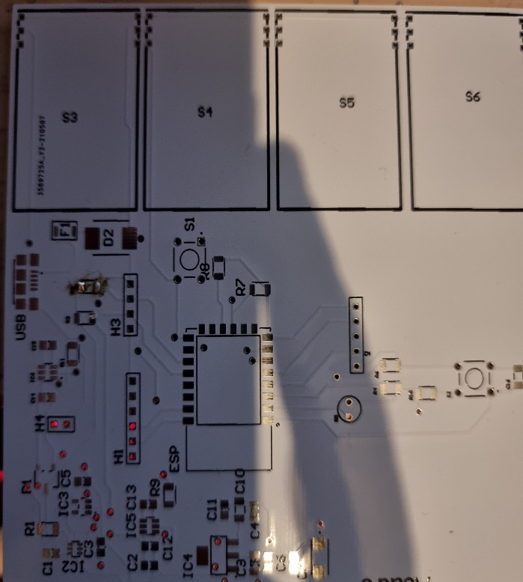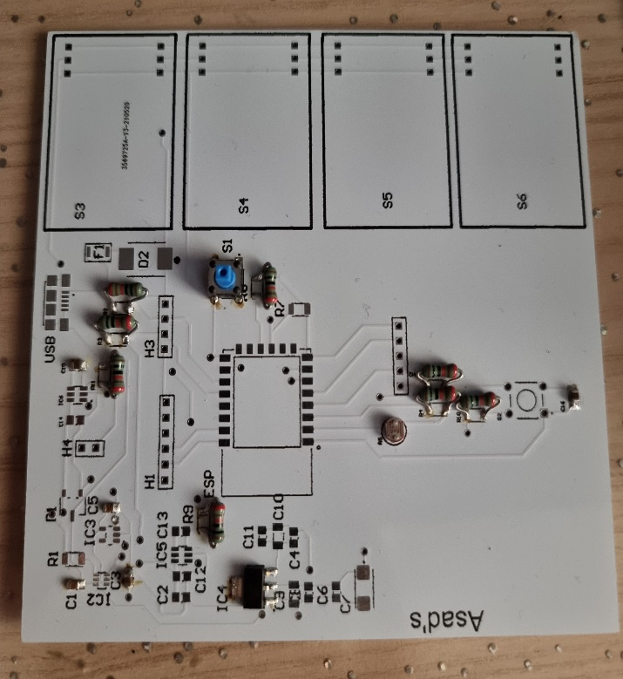

Figure 9: Wrong PCB Figure 0: Incomplete PCB

# 5 Reference list

|  |  |
| --- | --- |
| [1] | C. d. Bruijn, „RGB clock,” https://www.elektormagazine.com/, Nederland, 2017. |
| [2] | „ESP-12E - WiFi Module,” https://components101.com/wireless/esp12e-pinout-datasheet#:~:text=ESP%2D12E%20is%20a%20miniature,SoC%20(System%20on%20Chip)., 17 October, 2018. |